**Date Submitted:**

**Task 01:**

Youtube Link:

<https://youtu.be/wpKVRQnxOE8>

40 MHz = 25 ns delay. The number of clock cycles for a 0.425s delay is 0.425s/25ns = 17000000. since SysctlDelay(x) takes 3*x cycles; 17000000/3 = 5666667.

in the first picture the clock cycle counter is reset to 0 (note: the value shown is not reset until the next clock cycle, thus the value shown is not the actual value which is 0)

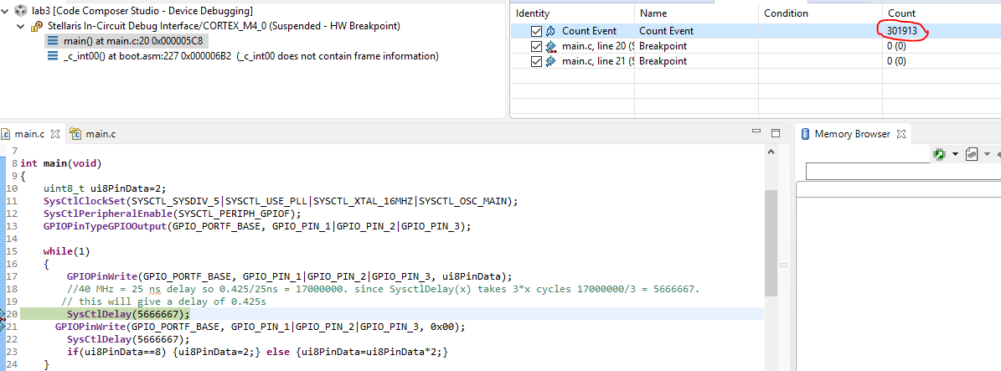

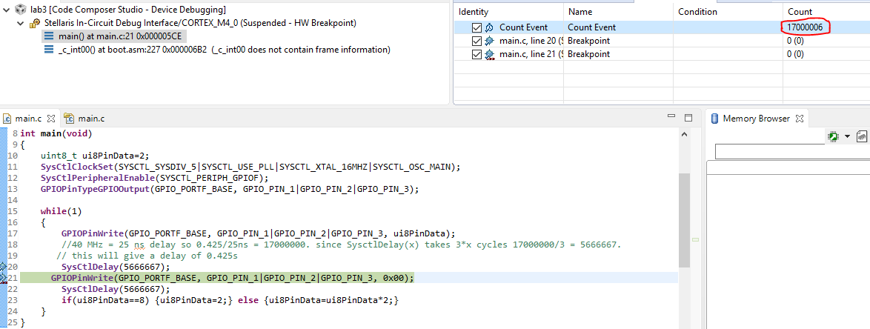

The total count of 17000006 informs us that based on the 40MHz clock the delay is roughly 0.425s.

**Modified Code:**

**#include <stdint.h>**

**#include <stdbool.h>**

**#include "inc/hw_memmap.h"**

**#include "inc/hw_types.h"**

**#include "driverlib/sysctl.h"**

**#include "driverlib/gpio.h"**

**int main(void)**

**{**

**uint8_t ui8PinData=2;**

**SysCtlClockSet(SYSCTL_SYSDIV_5|SYSCTL_USE_PLL|SYSCTL_XTAL_16MHZ|SYSCTL_OSC_MAIN);**

**SysCtlPeripheralEnable(SYSCTL_PERIPH_GPIOF);**

**GPIOPinTypeGPIOOutput(GPIO_PORTF_BASE, GPIO_PIN_1|GPIO_PIN_2|GPIO_PIN_3);**

**while(1)**

**{**

**GPIOPinWrite(GPIO_PORTF_BASE, GPIO_PIN_1|GPIO_PIN_2|GPIO_PIN_3, ui8PinData);**

**//40 MHz = 25 ns delay so 0.425/25ns = 17000000. since SysctlDelay(x) takes 3*x cycles 17000000/3 = 5666667.**

**// this will give a delay of 0.425s**

**SysCtlDelay(5666667);**

**GPIOPinWrite(GPIO_PORTF_BASE, GPIO_PIN_1|GPIO_PIN_2|GPIO_PIN_3, 0x00);**

**SysCtlDelay(5666667);**

**if(ui8PinData==8) {ui8PinData=2;} else {ui8PinData=ui8PinData*2;}**

**}**

**}**

**------------------------------------------------------------------------------------**

**Task 02:**

Youtube Link:

<https://youtu.be/Ul0688uy7O8>

**Modified Code:**

**#include "inc/hw_memmap.h"**

**#include "inc/hw_types.h"**

**#include "driverlib/sysctl.h"**

**#include "driverlib/gpio.h"**

**int main(void)**

**{**

**uint8_t ui8PinData=2;**

**SysCtlClockSet(SYSCTL_SYSDIV_5|SYSCTL_USE_PLL|SYSCTL_XTAL_16MHZ|SYSCTL_OSC_MAIN);**

**SysCtlPeripheralEnable(SYSCTL_PERIPH_GPIOF);**

**GPIOPinTypeGPIOOutput(GPIO_PORTF_BASE, GPIO_PIN_1|GPIO_PIN_2|GPIO_PIN_3);**

**while(1)**

**{**

**GPIOPinWrite(GPIO_PORTF_BASE, GPIO_PIN_1|GPIO_PIN_2|GPIO_PIN_3, ui8PinData);**

**//40 MHz = 25 ns delay so 0.425/25ns = 17000000. since SysctlDelay(x) takes 3*x cycles 17000000/3 = 5666667.**

**// this will give a delay of 0.425s**

**SysCtlDelay(5666667);**

**GPIOPinWrite(GPIO_PORTF_BASE, GPIO_PIN_1|GPIO_PIN_2|GPIO_PIN_3, 0x00);**

**SysCtlDelay(5666667);**

**//for the sequence R, G, B, RG, RB, GB, RGB, R, G, ...**

**// R = 2, B = 4, G = 8. thus a mapping from blink to the next is made based on the change in value**

**if(ui8PinData==2 | ui8PinData==4 | ui8PinData== 6) {ui8PinData=ui8PinData+6;} // R->G, B->RG, RB->GB: add 6 to current value**

**else if (ui8PinData==8 | ui8PinData==10) {ui8PinData=ui8PinData-4;} // G-> B, RG-> RB: subtract 4 from current value**

**else if (ui8PinData==12) {ui8PinData=ui8PinData+2;} // if GB add 2 to get to RGB**

**else {ui8PinData=2;} // if RGB or any other non specified value occurs, go to R**

**}**

**}**